**LAB # 06**

**INTRODUCTION TO MATLAB**



**Spring 2024**

**CSE-301L**

**Operating System Lab**

Submitted by: **NAVEED AHMAD**

Registration No.: **22PWCSE2165**

Class Section: **B**

“On my honor, as student of University of Engineering and Technology, I have neither given nor received unauthorized assistance on this academic work.”

Submitted to:

**Dr. Safdar Nawaz Khan Marwat**

April 28, 2024.

Department of Computer Systems Engineering

University of Engineering and Technology, Peshawar

## **LabObjective(s):**

* **Generating sinusoid**
* **Addition of sinusoid with variation in parameters and their plots**
* **Linear phase shift concept when dealing with sum of sinusoid**

## **Task # 01:**

**Generate the 1x10 row vector *v* whose *i*‐th component is cos (iπ/4).**

## **Problem Analysis:**

**In this task we generate a row vector v whose i-th component is cos(iπ/4)**

## **Algorithm:**

* **Start loop from 1 to 10 with a sample rate of 1/10**
* **Make a signal cos whose i-th component is cos(iπ/4)**

**Code:**

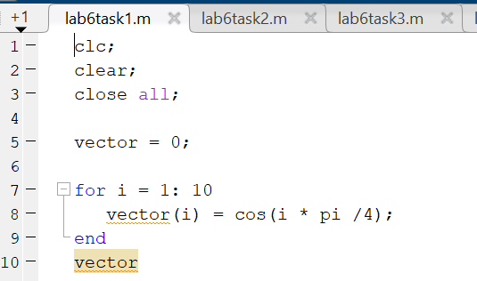

**Output:**

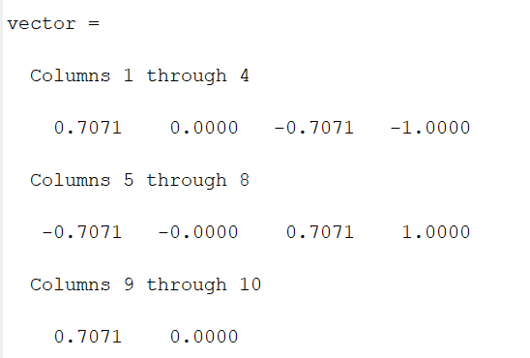

**Task # 2:**

**Write matlab code that draw graphs of sin (nπx) on the interval ‐1≤x≤1 for n = 1, 2, 3, …, 8. (Hint: Use for loop)**

## **Problem Analysis:**

**In this task we are asked to to draw a graph of sin (nπx) on the given interval ‐1≤x≤1 for n = 1, 2, 3, …, 8.**

## **Algorithm:**

* **Take the range of the signal from 1 – 8**
* **Now using loop draw the graph of the signal from 1 – 8**
* **Subplot all the graph on one window**

**Code:**

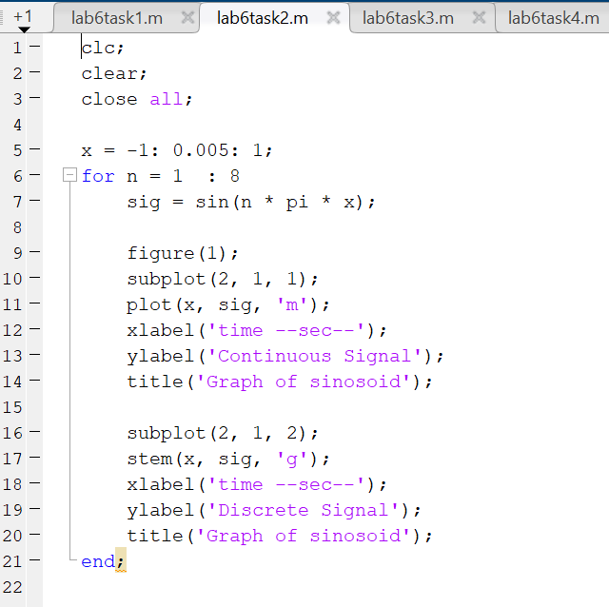

**Output:**

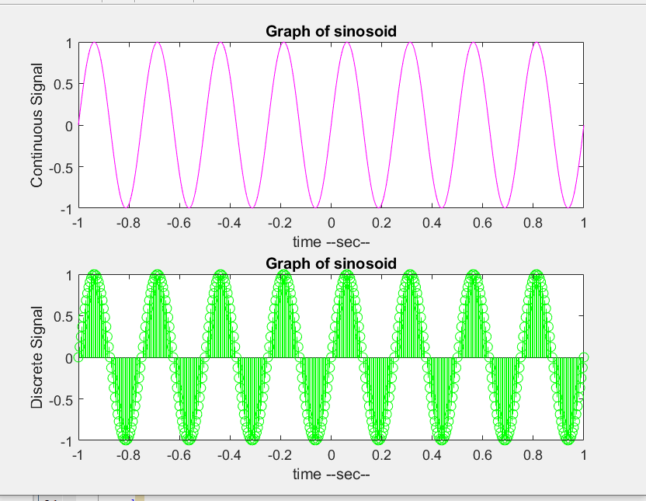

**Task # 3:**

**Given the signal exp(‐x)sin(8x) for 0≤x≤2π, plot its continuous‐time and discrete‐time representations. Use subplot and label properly.**

## **Problem Analysis:**

**In this task we have to draw continuous and discrete –time signal using subplot of the given signal.**

## **Algorithm:**

* **Take the range of the signal from 0-2π**
* **Now get the exponential signal using exp(-x)**
* **Make sinusoidal signal sin(8*x)**
* **Multiply both the signal**
* **Plot using subplot command on one window**
* **Plot continuous and discrete-time signal**

**Code:**

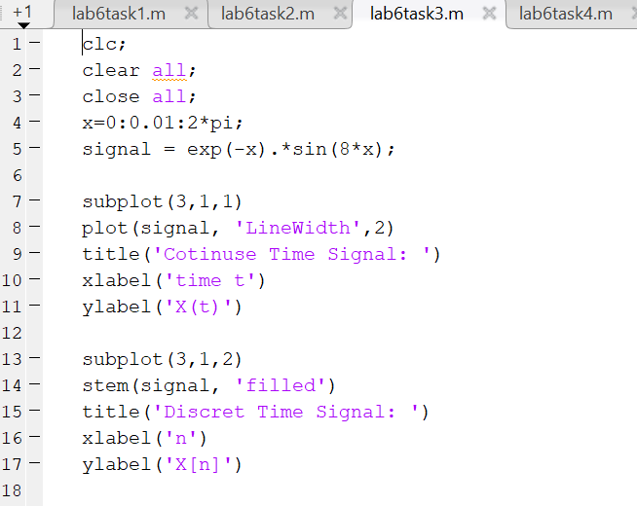

**Output:**

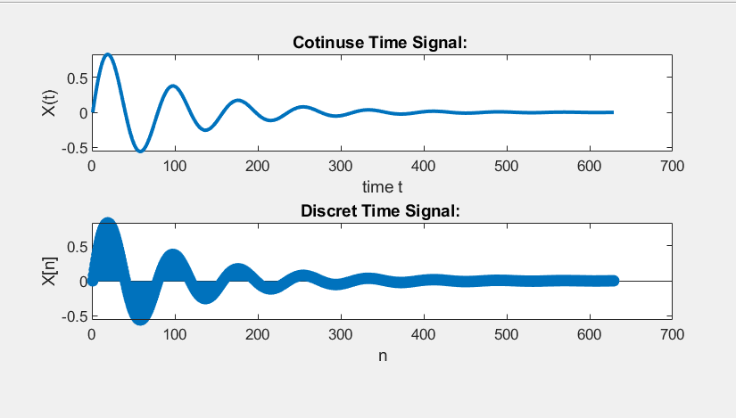

**Task # 4:**

**Modify the example given in topic 6.2 to generate a sine wave with phase shift of +pi/2. Then plot a cosine wave of same frequency, amplitude, and phase shift of 0 in another subplot. Compare both the signals and determine the relationship between the two.**

## **Problem Analysis:**

**In this task we have to generate two signals one signal using sin function whose phase shift is +pi/2 and another signal is cosine whose frequency, amplitude, remain the same as for sin function but the phase shift of cosine function must be zero(0).**

## **Algorithm:**

* **First take a frequency which devide the time**
* **Then take time from -3 to +3 with a sample rate of 1/fs**
* **Then take amplitude of the signal**
* **Make the phase of the signal pi/2**
* **Make the signal using sin function**
* **Plot the signal**
* **Then take another cosine signal**
* **With the same frequency , amplitude but phase must be zero**
* **Plot the cosine signal**

**Code:**

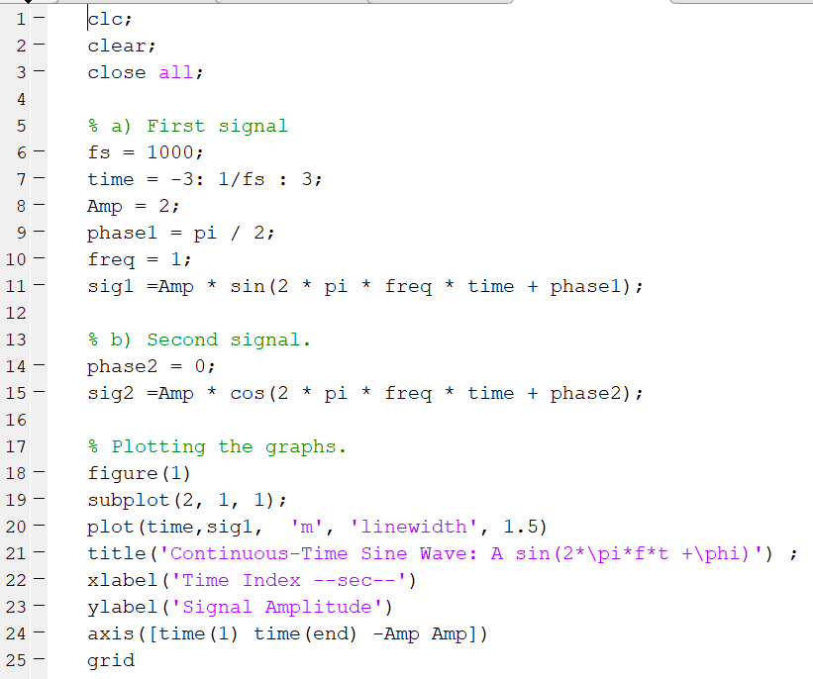

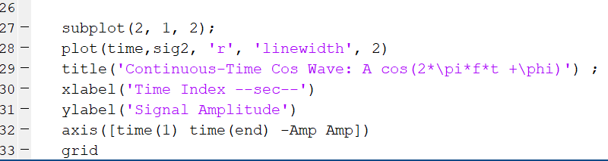

**Output:**

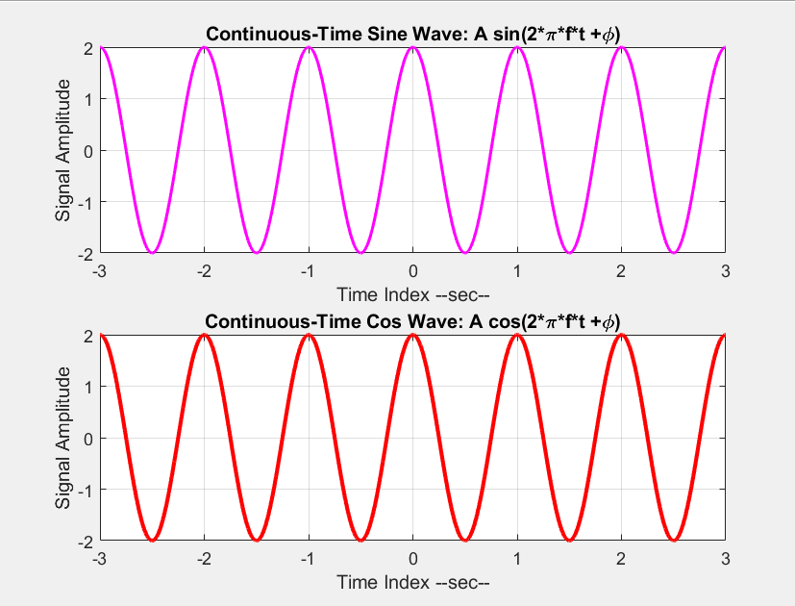

**Task # 5:**

**Write a program to generate a continuous‐time sine wave of frequency 3 Hz, positive phase shift of pi/2, and amplitude of 5. Also generate a continuous‐time cosine wave of frequency 3 Hz, amplitude of 5, and phase shift of 0. Plot the two signals on separate subplots and properly label them. Determine the relationship between the two signals.**

## **Problem Analysis:**

**In this task we have to generate two continuous time signal having frequency 3 Hz, amplitude 5 and phase shift of pi/2 and zero.**

## **Algorithm:**

* **Make amplitude 5 and frequency 3**
* **Take range of the signal from -3 to 3 with a sample rate of 1/900**
* **Make phase of the signal pi/2 and plot the cosine continuous time signal**
* **Make frequency of 3 and amplitude of 5**
* **Generate the signal and plot the sin continuous time signal**

**Code:**

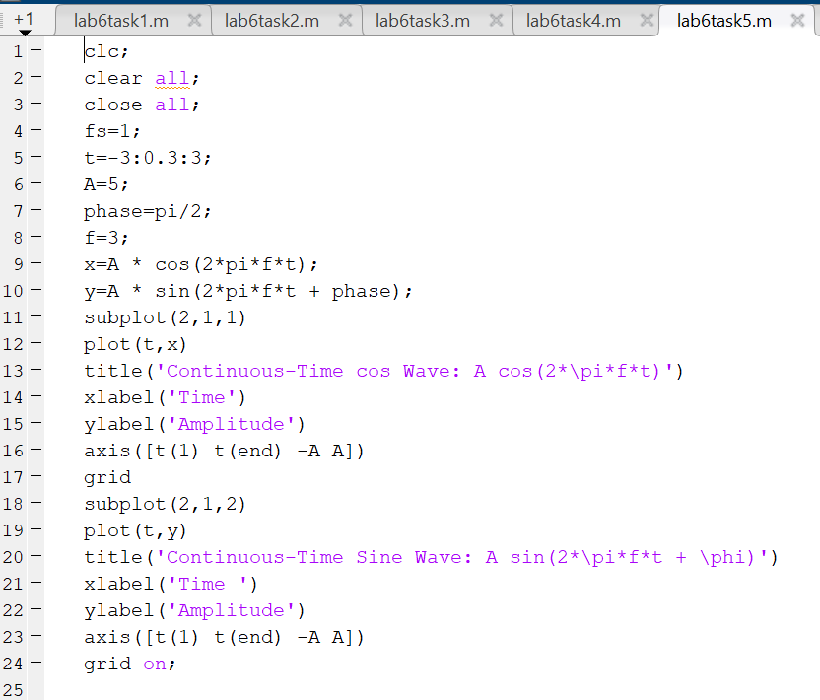

**Output:**

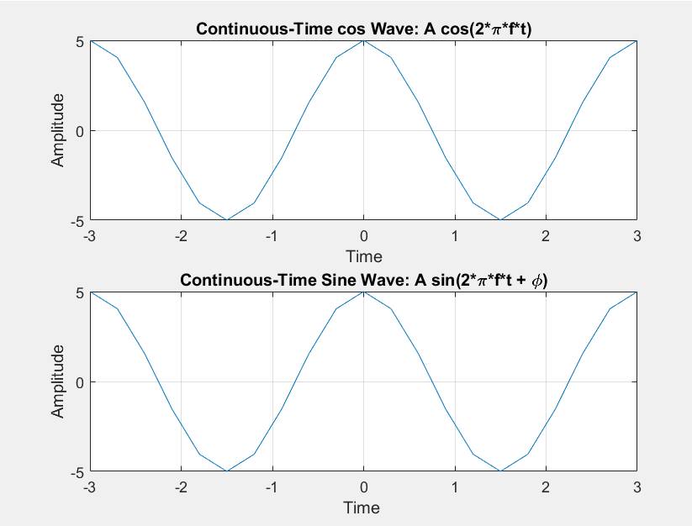

**Task # 6:**

**Write a general program that takes ‘n’ sinusoids from user of same frequency, amplitude, and phase. Plot the individual sinusoids & the resultant using subplot function on same figure. Do perform proper labeling. Note: Take the amplitude, frequency, and phase given in example of case 1. Run the code for different values of n and state the result on paper.**

## **Problem Analysis:**

**In this task we have written a program that takes n sinusoid from user of the same frequency, amplitude, and phase . and plot the signals individually and also on the same window using subplot .and also run the code for the different values of n.**

## **Algorithm:**

* **Take range of the signal from -2 to 3 with sample rate of 0.01**
* **Take amplitude of the signal as 5 and input the sinusoid from the user**
* **Using loop to plot n number of sinusoid**
* **And the sum them**
* **Plot the resultant of the signals**

**Code:**

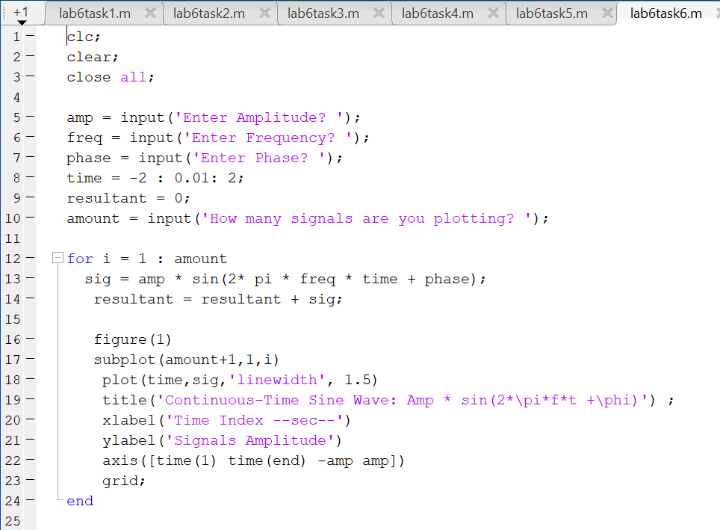

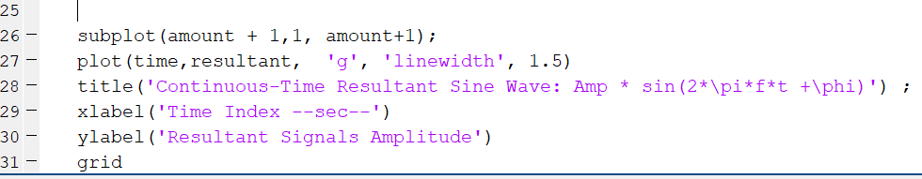

**Output:**

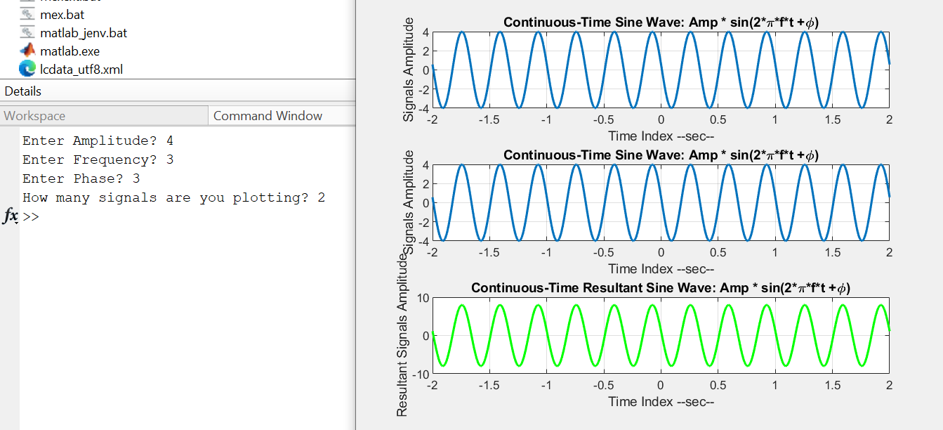

**Task # 7:**

**Write a general program that takes ‘n’ sinusoids from user of same frequency and phase with varying amplitudes. Take amplitude from user on run time. Plot the individual sinusoids & the resultant using subplot function on same figure. Do perform proper labeling. Note: Take the amplitude and frequency given in example of case 2. Run the code for different values of n and state the result on paper.**

## **Problem Analysis:**

**In this task we have ask to enter n number of sinusoid from user having the same frequency and phase but with varying amplitudes. And plot the sinusoids individually and also we are asked to plot the resultant of the sinusoids.**

## **Algorithm:**

* **Take range of the signal from -2 to 2 with sample rate of 0.01**
* **Take input the number of sinusoids from user**
* **Using loop to plot n numbers of sinusoid**
* **In loop ask to enter the amplitude of the signal from user**
* **Plot the signal using subplot**
* **Sum all the signal**

**Code:**

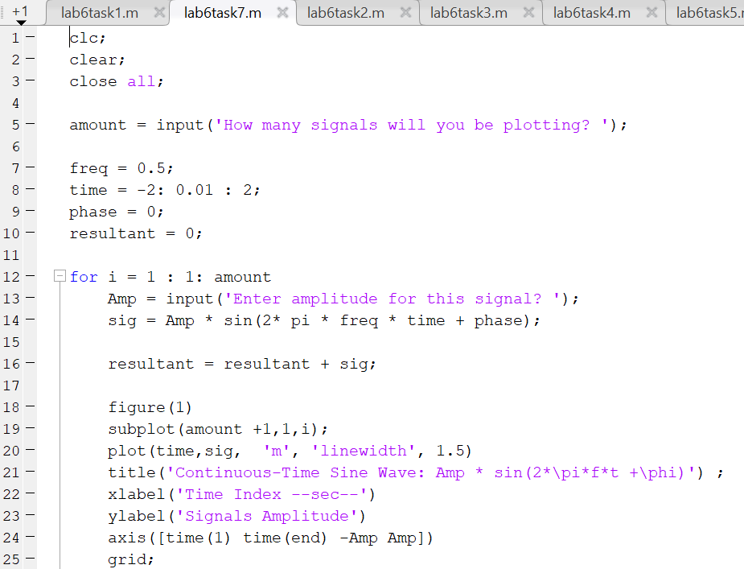

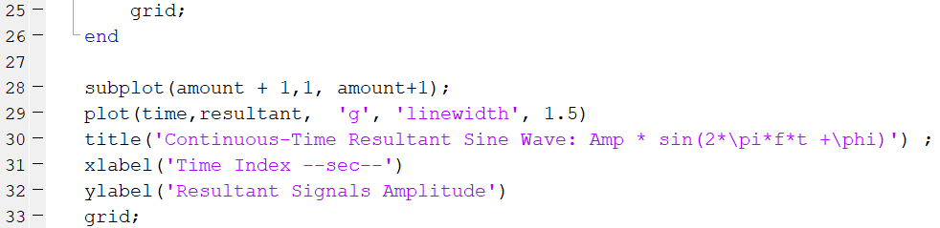

**Output:**

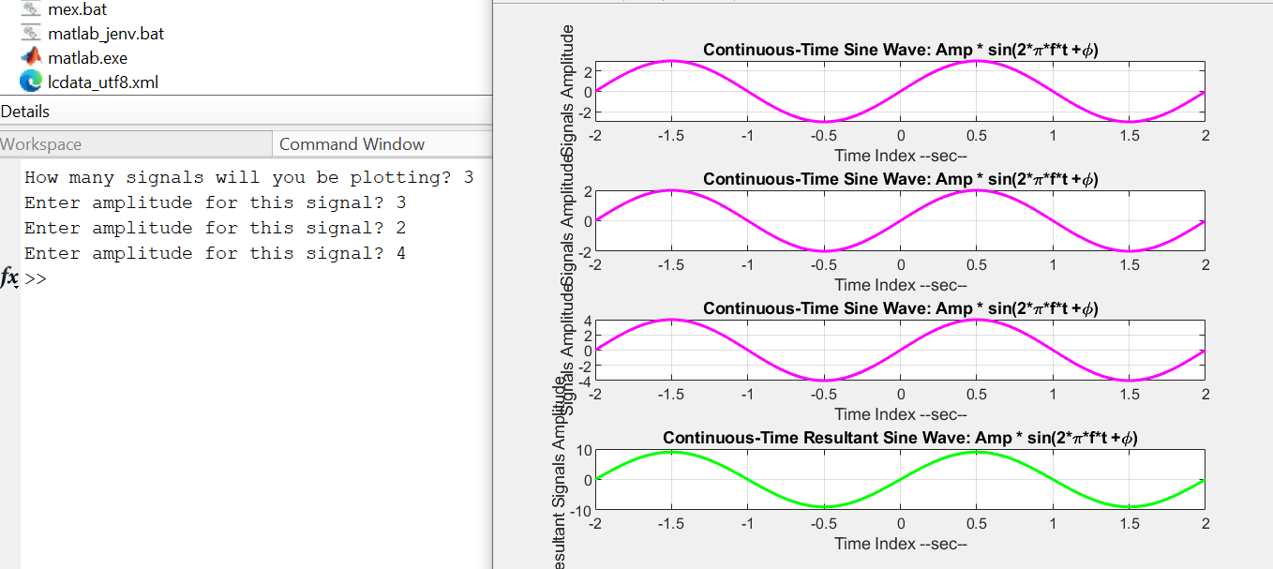

### **Task # 8 :**

**Write a general program that takes ‘n’ sinusoids from user of same amplitude and phase with varying frequencies. Take each frequency from user on run time. Plot the individual sinusoids & the resultant using subplot function on same figure. Do perform proper labeling. Note: Take the amplitude and phase given in example of case 3. Run the code for different values of n and state the result on paper.**

## **Problem Analysis:**

**In this task we have asked to plot n number of sinusoids by taking input from user having the same amplitude and phase but varying frequencies . and plot them individually and also plot the resultant using subplot command on the same window.**

## **Algorithm:**

* **Take range of the signal**
* **Give amplitude of the signal as 4**
* **Take input the number of sinusoids from users**
* **Use loop for plotting n number of sinusoids**
* **In loop take input the frequency from user**
* **Then plot the continuous time signal**
* **Then add the signal**
* **And also plot the resultant signal**

**Code:**

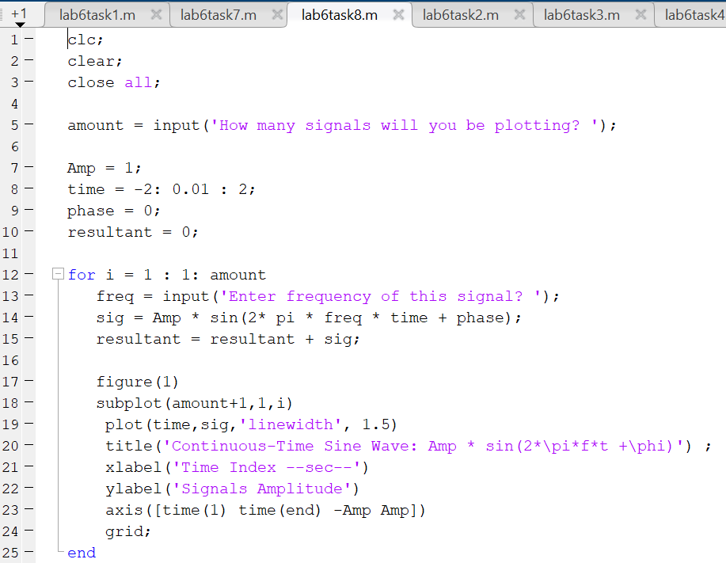

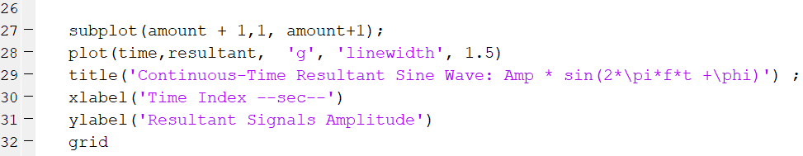

**Output:**

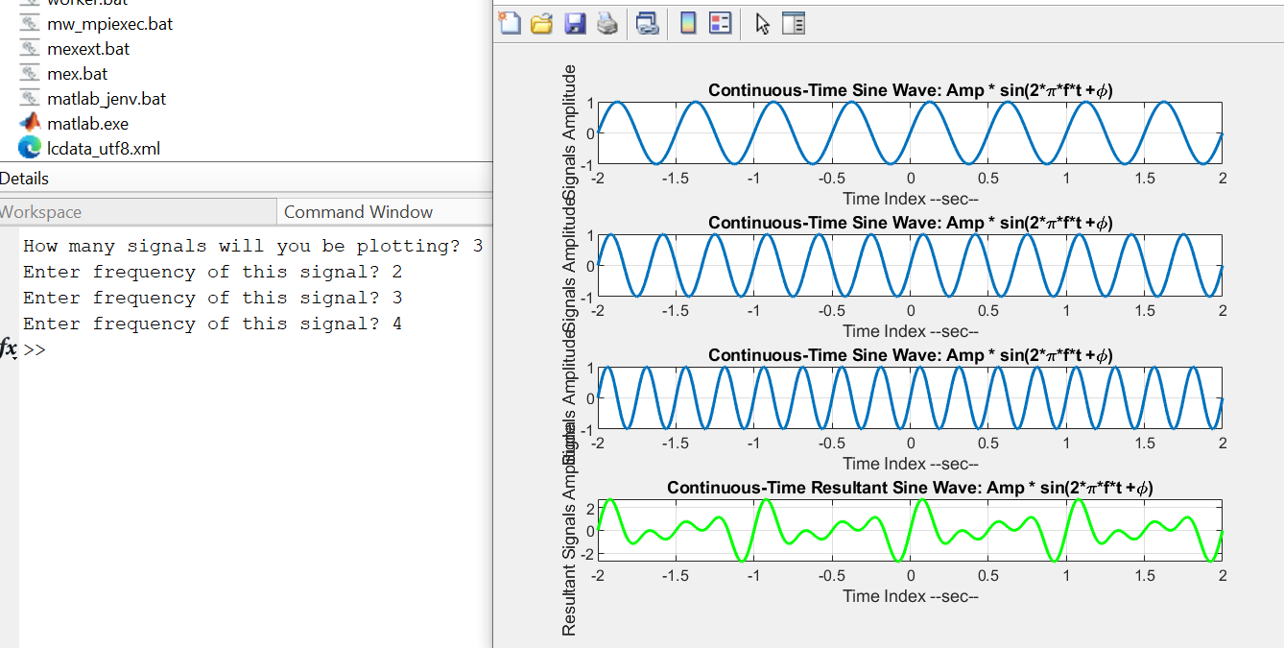

**Task # 9:**

**Write a general program that takes ‘n’ sinusoids from user of same amplitude and frequency with varying phases. Take each phase from user on run time. Plot the individual sinusoids & the resultant using subplot function on same figure. Do perform proper labeling. Note: Take the amplitude and frequency given in example of case 4. Run the code for different values of n and state the result on paper.**

## **Problem Analysis:**

**In this task we have asked to plot n number of sinusoids by taking input from user having the same amplitude and frequency but varying phases . and plot them individually and also plot the resultant using subplot command on the same window.**

## **Algorithm:**

* **Take range of the signal**
* **Give amplitude of 4**
* **Take input the number of sinusoids**
* **Use loop to plot n number of signals**
* **Inside the loop take input the phase of the signal then plot the signal**
* **Sum up all the signal**
* **Outside the loop plot the resultant signal**

**Code:**

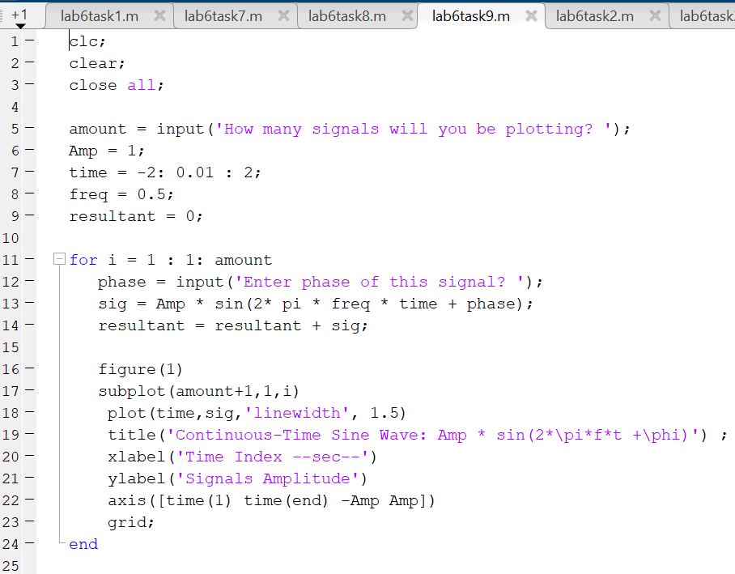

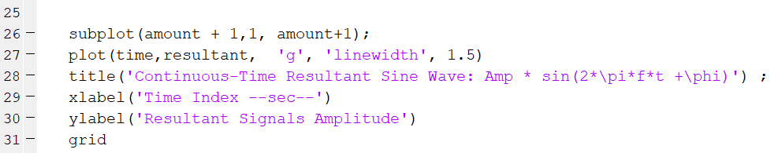

**Output:**

